**Possible App Changes & Promotion Strategy**

14.10.2024

Om Patel

**MonkeyBox**

**Overview**

Suggestions for improvements in the app based on customer interaction and their common concerns and creating promotional banners to encourage customers to recharge wallets and buy meal plans.

**Goals**

1. Eliminate hygiene doubts before placing an order
2. Improve customer care reach
3. Creating Psychological acceptance - by making use of MB as a worthwhile benefit to them
4. Encourage users to opt for subscriptions.
5. Make the price comparison and benefits evident with meal plan subscriptions.

* **Easy Access to Customer Care**
  + Rename the Help section as “Contact US”
* **Know More Section**
  + The little symbol on the left-hand side of the hamburger menu button
    - Contains Kitchen Process Videos - proof of hygiene
    - Packaging videos(we can add this to our banner)

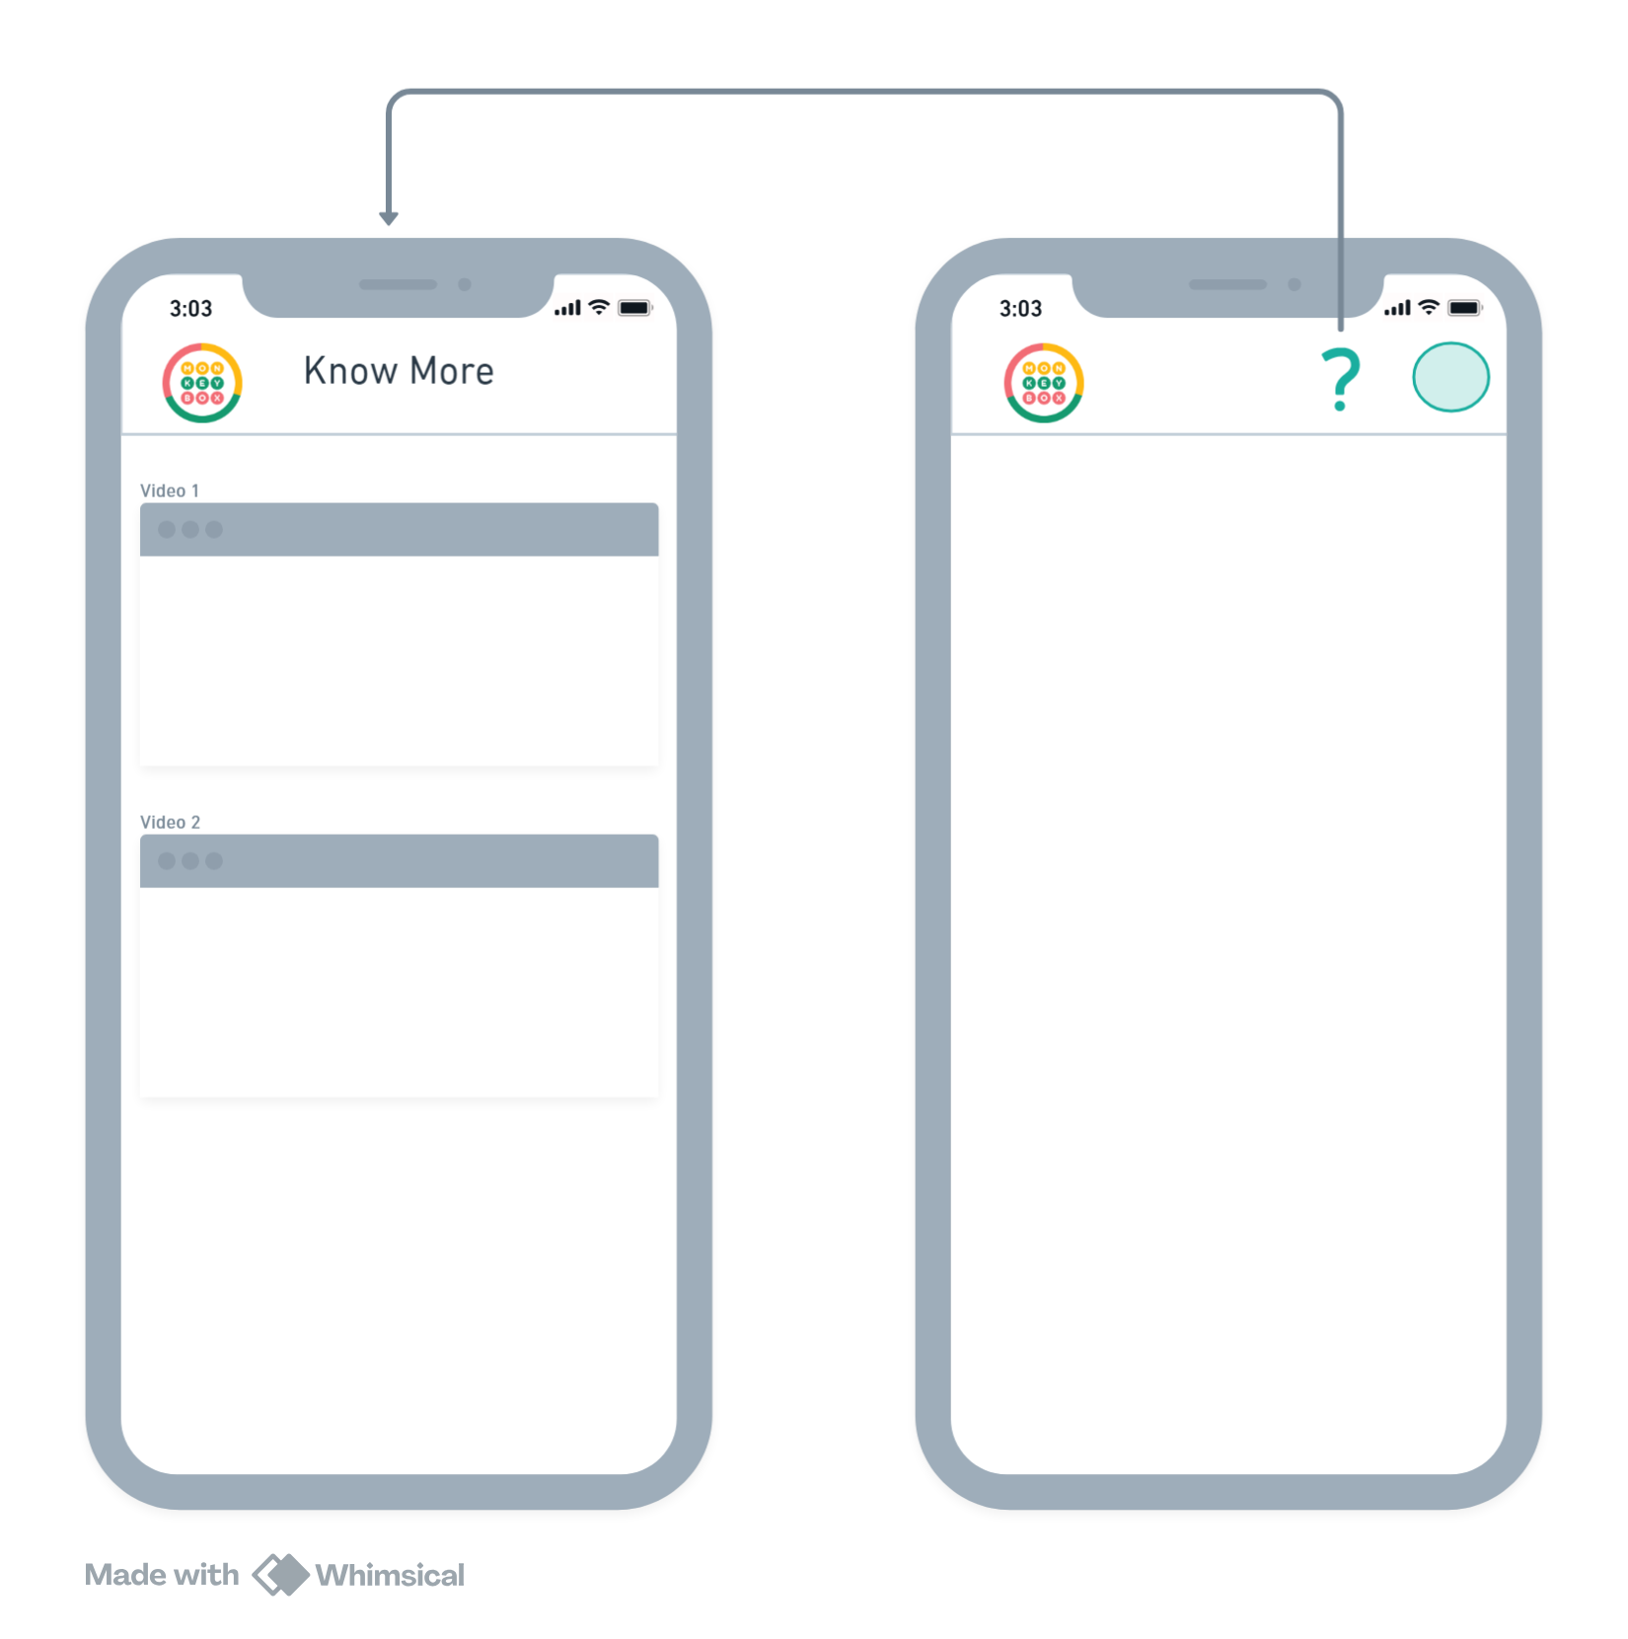

* **Order Cutoff time**
  + Push notifications to regular users before closing the window if an order has not been placed for that day
* **Capitalize on FOMO**
  + Showcase the current number of children using MonkeyBox service from that School. Creating a safe way to trust the MonkeyBox.
* **Make MB worth their use**
  + That's the mission of MB - to save time and get rid of morning hassle for parents

**Brief of the solution**.

* We will introduce a Time Saver Tracker in the MonkeyBox app to monitor the total time users save by opting for our services instead of preparing themselves.
* The tracker will have a visual representation, updating based on usage. Once a user reaches specific time-saving milestones (e.g., 10 hours saved), they will be rewarded with discounts, exclusive offers, or loyalty perks. This encourages continued use and fosters a personalized connection to the service.
* Rewards will reinforce the value users gain from the service, especially Loyal user
* Sharing of time-saved achievements for social media stories and status
* **Promotion Strategy**

**Summary of Prices Per Day:**

| Plan Name | Breakfast Price | Lunch Price | Snacks Price |
| --- | --- | --- | --- |
| Ad-Hoc | 75/125 | 125/165/195 | 70/90 |
| L 5 days (795) | - | 159 | - |
| L 10 days (1495) | - | 149.5 | - |
| B+L 5 days (1195) | 90 | 149 | - |
| B+L 10 days (2195) | 82.5 | 137 | - |
| B+L+S 5 days (1395) | 77.5 | 129 | 72.33 |
| B+L+S 10 days (2595) | 72 | 120 | 67.27 |

1. **Homepage Banner (Subscriptions)**

* Lunch Only Plan
  + - Get our premium nutrition lunch at just [cross 195] 149
    - 5 day plan starts at 795 only

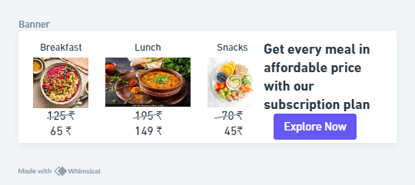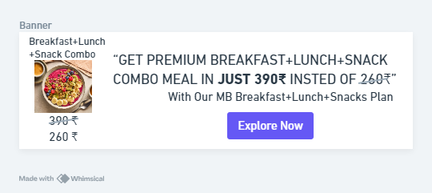  
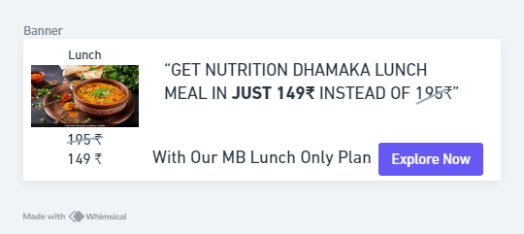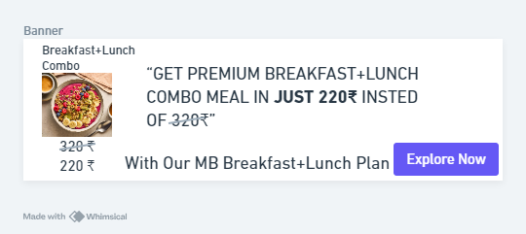

**B) Cart page Price Benefit (Subscriptions)**

* Actual side by side price benefits

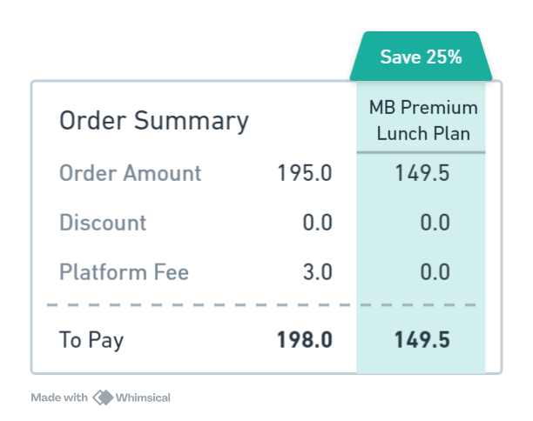

**C) Cart page Price Benefit pop up (Subscriptions)**

* Actual side by side price benefits

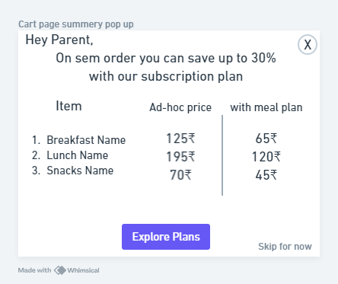

**D) Cart page Banner (Subscriptions)**

* If only lunch is added to the cart then Show the Lunch subscription banner, similarly for B+L show the B+L meal plan

**E) Home Page (Recharge)**

* Wallet recharge cashback offers

**F) Home Page (Pop-Up Page)**

* After the app opens, Pop Up page showcasing one pager info about meal plans encourage to checkout and look for options

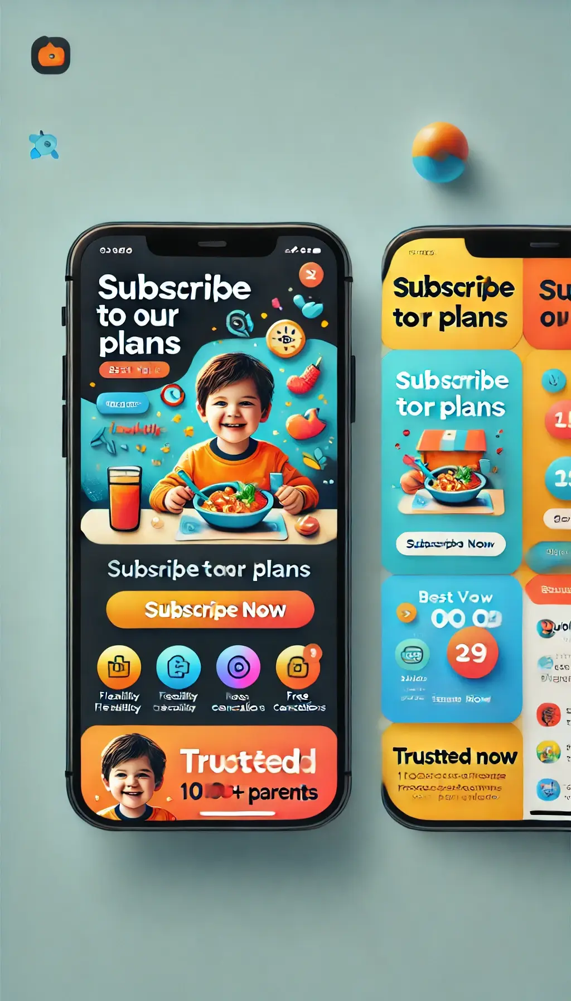

**G) Subscription Page**

1. Prominent “Subscribe Now” button. The green buttons are good but might benefit from a more distinctive colour or a “glowing” effect.
2. Include badges like "Trusted by 1000+ Parents" or "Top-Rated Meal Service" to build credibility.
3. Compress Details: Use collapsible sections for each plan where users can click to view more detailed benefits